Group-32

Harsh Patel – 100852669

Raquim Dockery 100660304

Christopher Fowler 100711442

Capstone Project DCOM 4100

Pings

Table of Contents

Connectivity From HO-Toronto to BR-Oshawa 2

Connectivity From BR-Oshawa to HO-Toronto 2

Connectivity From HO-Toronto to Web Server 3

Connectivity From BR-Oshawa to Web Server 3

Connectivity From HO-Toronto to ISP1, ISP2, ISP3 4

Connectivity From BR-Oshawa to ISP1, ISP2, ISP3 4

# Connectivity From HO-Toronto to BR-Oshawa

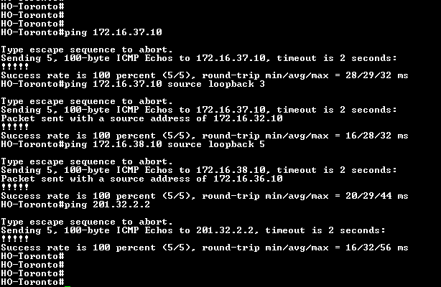

# Connectivity From BR-Oshawa to HO-Toronto

# Connectivity From HO-Toronto to Web Server

# Connectivity From BR-Oshawa to Web Server

# Connectivity From HO-Toronto to ISP1, ISP2, ISP3

# Connectivity From BR-Oshawa to ISP1, ISP2, ISP3

